B. Describe the purpose of this data analysis by doing the following:
1. Summarize one research question that is relevant to a real-world organizational situation captured in the selected dataset and that you will answer using time series modeling techniques.
Can we forecast daily revenue for the next 30 days based on historical revenue data from the first two years of operation.
2. Define the objectives or goals of the data analysis. Ensure that your objectives or goals are reasonable within the scope of the scenario and are represented in the available data.
The goal is to develop a time series model to forecast daily revenue, enabling the organization to plan resources, optimize operations, and set realistic financial expectations for the next month.
C. Summarize the assumptions of a time series model including stationarity and autocorrelated data.
Stationarity:
The statistical properties of the time series (mean, variance, autocorrelation) do not change over time. Stationarity is essential for most time series models, including ARIMA. Time series data often exhibit autocorrelation, where past values influence future values.
D. Summarize the data cleaning process by doing the following:
1. Provide a line graph visualizing the realization of the time series.
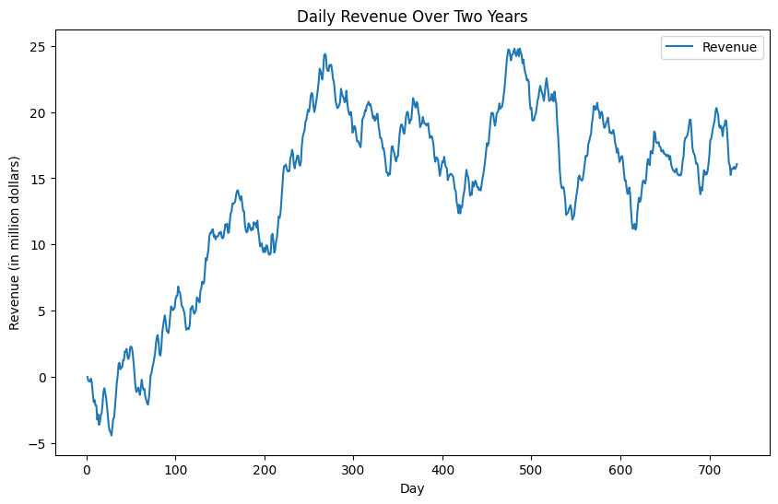
2. Describe the time step formatting of the realization, including any gaps in measurement and the length of the sequence.
3. Evaluate the stationarity of the time series. The p-value is less than 0.05 so the series is non-stationary
4. Explain the steps used to prepare the data for analysis, including the training and test set split. I handled the missing values, and I split the data into training (first 701 days) set and test (Last 30 days) set.
5. Provide a copy of the cleaned dataset. In attachments
E. Analyze the time series dataset by doing the following:
1. Report the annotated findings with visualizations of your data analysis, including the following elements:
• trends 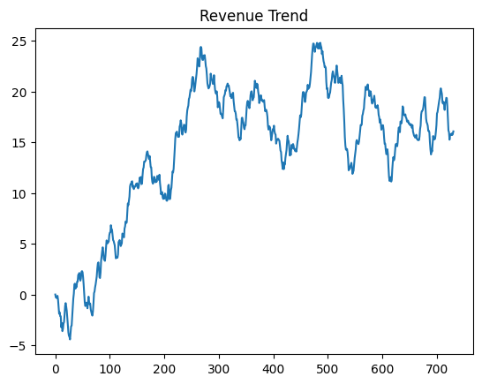
• the autocorrelation function
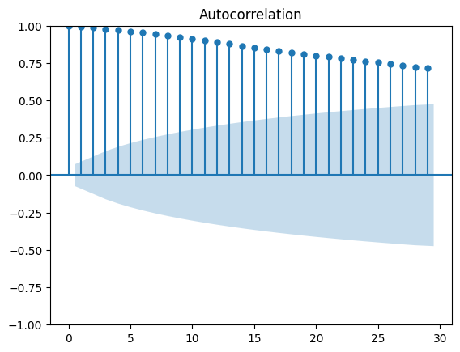
• the spectral density
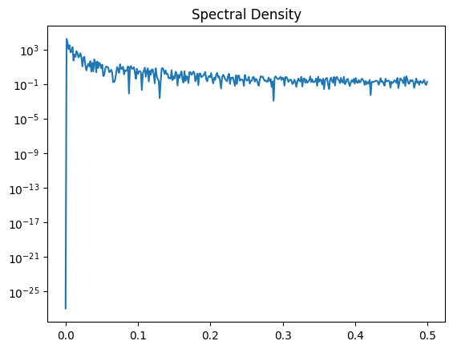
• the decomposed time series
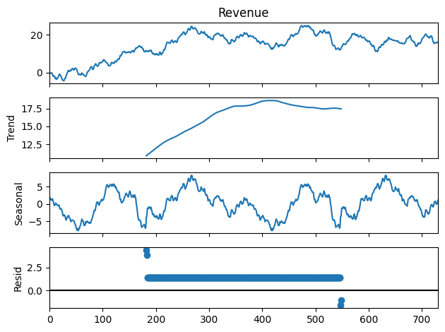
• confirmation of the lack of trends in the residuals of the decomposed series
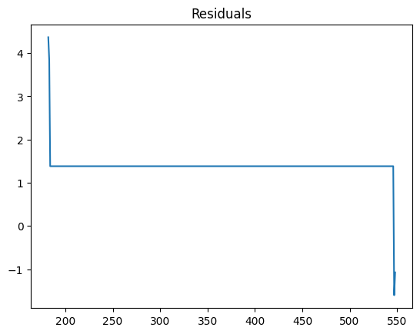
2. Identify an autoregressive integrated moving average (ARIMA) model that accounts for the observed trend and seasonality of the time series data.
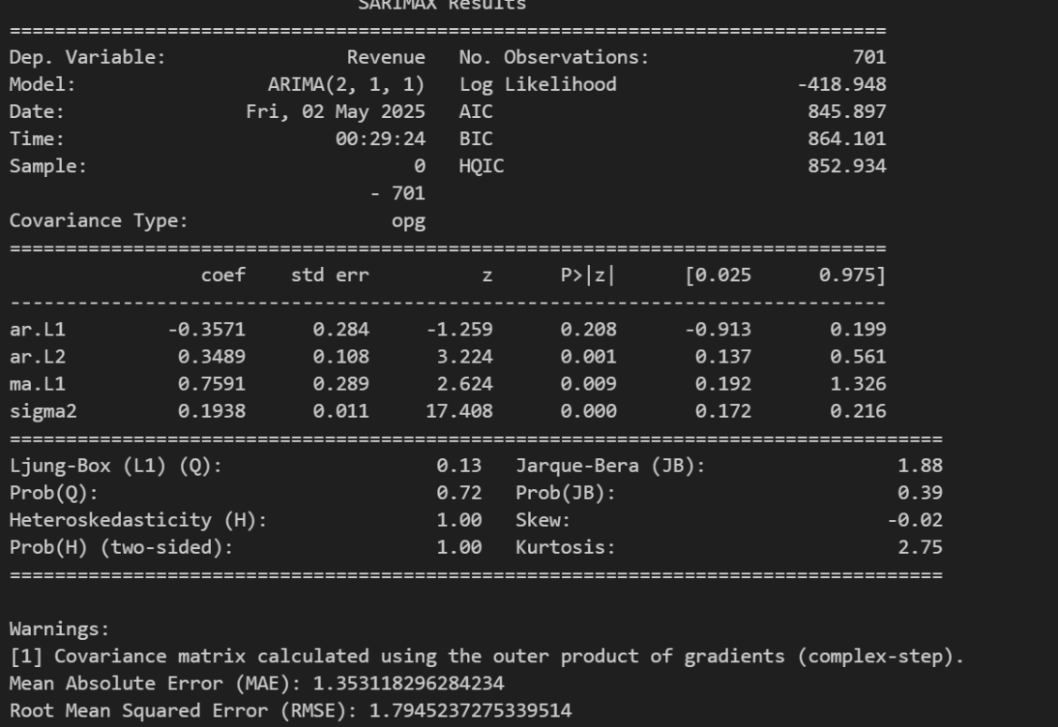
3. Perform a forecast using the derived ARIMA model identified in part E2.
4. Provide the output and calculations of the analysis you performed. Attached in files
F. Summarize your findings and assumptions by doing the following:
1. Discuss the results of your data analysis, including the following:
• the selection of an ARIMA model
(p,d,q)= (2,1,1)
• the prediction interval of the forecast
95 percent confidence interval
• a justification of the forecast length
30 days is reasonable for the business need of short term planning
• the model evaluation procedure and error metric
Mean absolute error measures the average magnitude of the errors in the forecast without considering their direction. Root mean square error, measures the square root of the average squared differences between actual and forecasted values.
2. Provide an annotated visualization of the forecast of the final model compared to the test set that includes the following:
• the original output with the new prediction line and confidence cone
• correct labeling
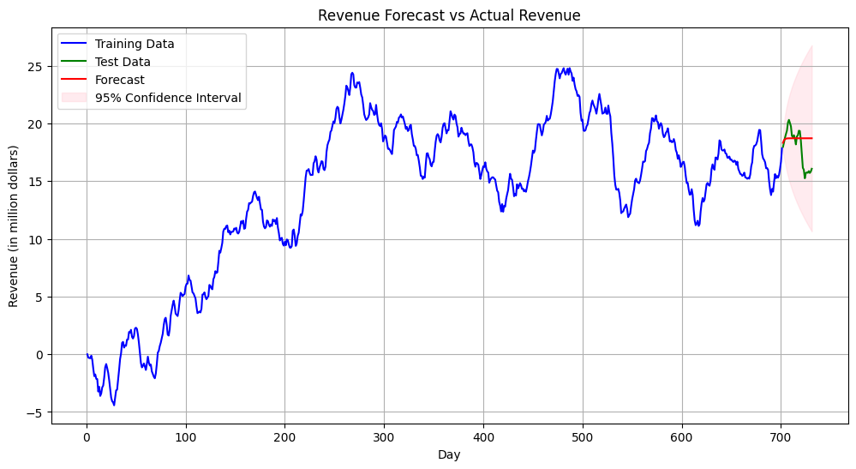
3. Recommend a course of action based on your results.
We should monitor actual revenue against the forecast to refine the model, and use the forecast to plan resources and set realistic revenue targets.
G. With the information from part E, create your report using an industry-relevant interactive development environment (e.g., an R Markdown document, a Jupyter Notebook). Include a PDF or HTML document of your executed notebook presentation.

